ANNUAL REPORT
APRIL 19-MARCH 20
CENTRE FOR ENVIRONMENT AND AGRICULTURAL DEVELOPMENT (CEAD)

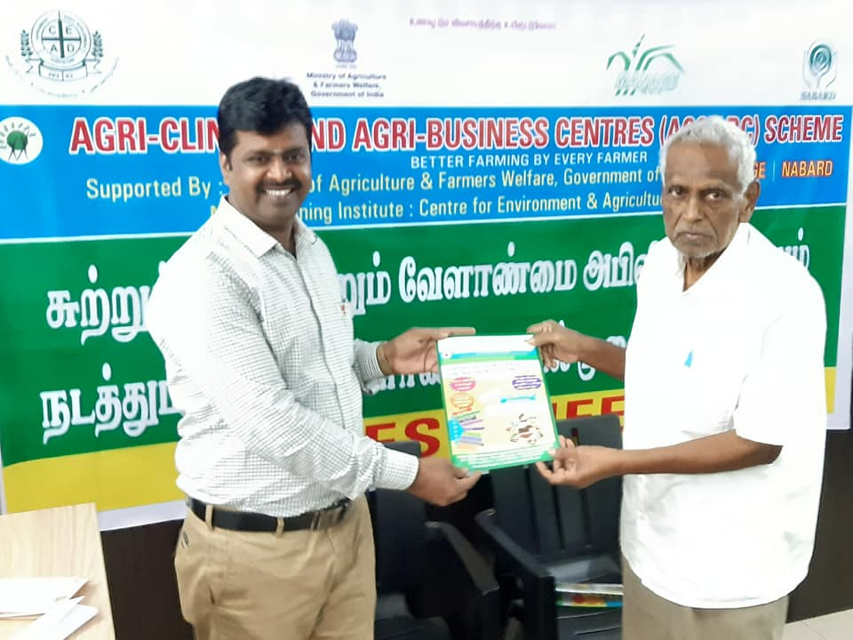
Regd.office Address
No.72, Nallavadu raod, Thavalakuppam, Puducherry -605007

INTRODUCTION:

CEAD is a non Governmental organization engaged in the betterment of farming communities particularly women and landless laborers through training them in environmentally sustainable income generation activities, introducing micro credits and improving their access to quality education and health services.

Since 2003, we've disseminated technologies through various trainings programme on Environmental, Education and health, water and sanitation, solid waste management, Organic farming , vermicompost and mushroom production etc, more than of 6000 participants from school children, college students, rural youth, rural women and farmers were participated .We've done this in collaboration with our grassroots level farmers, Agricultural department , NABARD and Reliance foundation. Our main motto is creating awareness for sustainable development through locally available resources.

ACTIVITIES CARRIED OUT

1. Health and Nutrition Training

2. Training on Roof Top Gardening

3. Training on Organic farming

4. Training on Micro irrigation technologies

5. Training on Mushroom Production

6. Training on Soil Health Management

7. Training on Vermi compost production

8. Strengthening of SHGs ( SHG Development )

OTHER ACTIVITIES

- Pradhan Mantri Koushal Vikas Yojana (PMKVY)
- ACACBC
- Organized- ICEACBS
- ACTIVITIES IN BRIEF:

1. Health and Nutritional programme:

The purpose of a nutrition intervention is to resolve nutrition problem by provision of advice & education. In rural areas due to lack of drainage facilities people facing many health hazards. In this context we have organized health and nutrional awareness camps for intake of balanced diet and mal nutrition. I addition that organized programme for establishment of nutrition garden in back yard of their houses , rural villages, school buildings and community land.

2.Training on Roof Top gardening

CEAD have initiated “Do it by yourself “gardening in the roof tops as an initial step, Setting up of Roof Top Garden to urban people with practical demonstration on planting techniques , integrated crop management practices. This training has been organized 25th of every month. Rural and urban women & Men were participated , Totally 10 batches of 150 women and Youth , and men group members were participated. In turn they have established roof top garden in their house and produced organic vegetables and leafy vegetables.

3. Training on Organic farming

The primary goal of organic agriculture is to optimize the health and productivity of interdependent communities of soil life, plants, animals and people. It Maintain soil health , Maintain Ecological balance ,Avoid Ground water and air pollution Maintain soil and crop productivity .Organic farming as a system of crop production is to feed the soil rather than feed the plant. CEAD organized various training programme regarding organic farming technologies to the farmers in developing their capacity and reviving their traditional knowledge on organic farming and Integrated framing technologies. Also imparted training on preparation of organic inputs like Panchakavya, EM, Vermiwash, Azolla cultivation and enriched farm yard manure. Training organized for School children and Agricultural college’s students regarding organic farming techniques and solid waste management techniques to conserve soil and water .During this financial year 300 farmers and students were participated. 60 students from PAJANCOA & Karaikal has been visited our farm established at Thavalakuppam for exposure of IFS and organic farming technologies.

4.Training on Micro Irrigation technologies

Training and consultation given on Micro irrigation technologies for ground nut , coconut sugarcane and roof top gardens. 150 farmers were participated in this training programme organized by CEAD

5.. Training on Mushroom Production

CEAD organized to enhance Nutrition through oyster Mushroom production training. Mushroom contains High Nutritional value, Protein content, 3-7% when fresh and 25- 40% when dry. . Consumption of mushrooms slows down the spread and effect of cancer, heart disease, HIV/AIDS (by boosting immune system). And for income generation and employment creation.
Training was given on compacted information on mushroom cultivation in relation to production, performance, problems and marketing. Totally 60 members participated and 5 were started Spawn production unit.

6. Training on Soil Health Management
Managing soil health means implementing practices. That either maintains or enhance the soil's physical, chemical, and biological attributes to improve soil functions. To enhance the soil helath through natural way CEAD organized one day training program (two training program) and trained 60 members for preparation of Bio inputs. One group started production of Bio inputs production under the name of green day and CEAD created marketing linkages
7. Training on Vermicompost Production
The Main objective of the organization is to promote sustainable agricultural practices for which Vermi compost play Vitol role. Vermicompost is a type of Organic Fertilizer. It is derived by composting organic waste by using various species of earthworms. It is a mixture of decomposing vegetable or food waste, bedding materials, and most importantly worm castings. This process of producing Vermicompost is called Vermicomposting. The said training programme imparted theory as well as practical (hand-on) exposure on vermicomposting and management of organic wastes in agriculture for productivity improvement and livelihood security. During the current financial year nearly 125 members were participated and more than 20 members had been involed in production process, CEAD have arranged marketing facilities. These producers linked with Department of Agriculture and Farmers welfare, Pondicherry and PKKVK - Puducherry
9. Strengthening of SHGs- SHG Development:
CEAD guiding formation of SHGs for empowerment, socio economic development of rural women. So for, 10 SHGs were formed in our working areas of Pondicherry and TamilNadu. 250 Members has been digitally literated through certified programme under National Digital Literacy Mission. NDLM. Financial literacy awareness programme also organized for the main objective of creation awareness among the SHG women on Need for Thrift and savings, usefulness and need of savings and availing credit linkage from the banks
10. Tree Planting
Our main objectives are ecofreindly and environment protection activities. In this regard we have planted 250 trees in and around of pudhucherry and school premises
OTHER ACTIVITIES
1.Organized Ineternational Conference on Agricultural, Environmental, Chemical and Bilogical scinces( ICAECBS)
2.Agriclinic and Agri Management Centers-(ACABC) Free Training programme had been conducted for setting Agri clinc and Agri business centers.

3. PMKVY is the flagship scheme of the Ministry of skill Development Entrepreneurship (MSDE)implemented by national Skill Development Corporation. The Objective of this skill certification Scheme is to enable a large number of Indian youth to take up industry-relevant skill training that will help them in securing a better livelihood. Individuals with prior learning experience or skills will also be assessed and certified under Recognition of Prior Learning (RPL). During this financial year CEAD have conducted many EDP training programme .

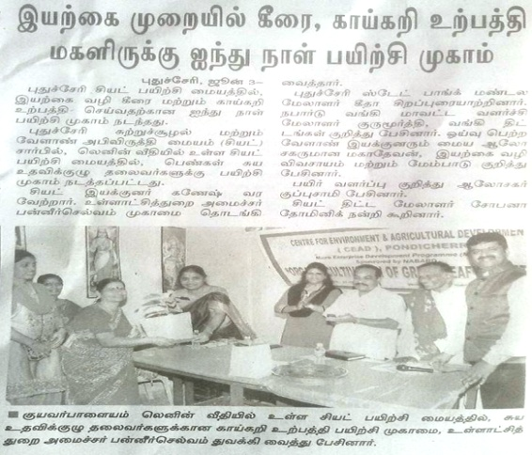
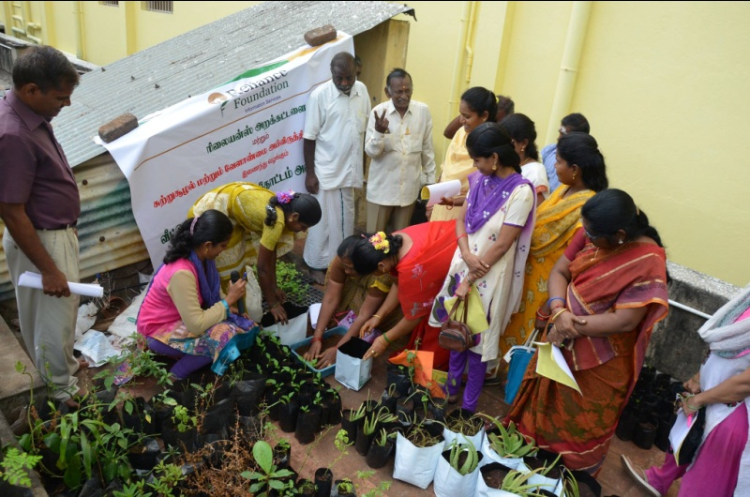
TRAINING ON ORGANIC VEGETABLE CULTIVATION, ROOF TOP GARDENEING

TRAINING ON MICRO IRRIGATION TECHNOLOGIES

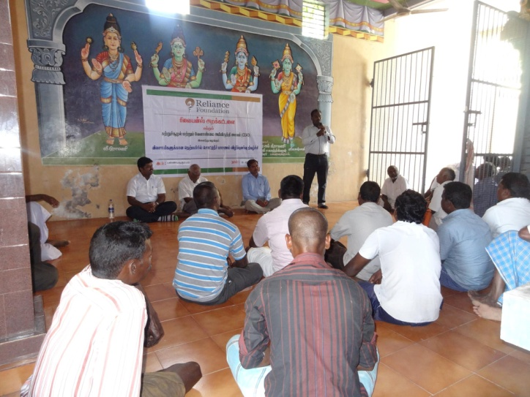

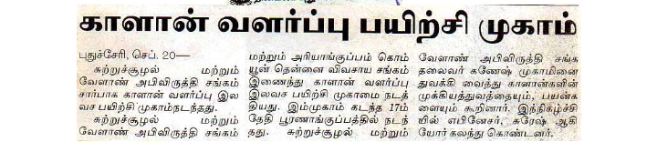
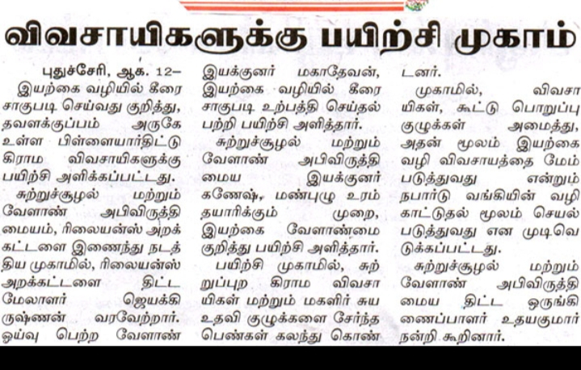

STUDENTS EXPOSURE VISIT- OUR FARM ACTIVITIES

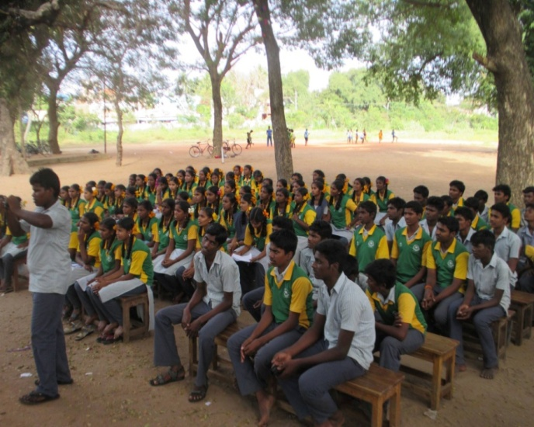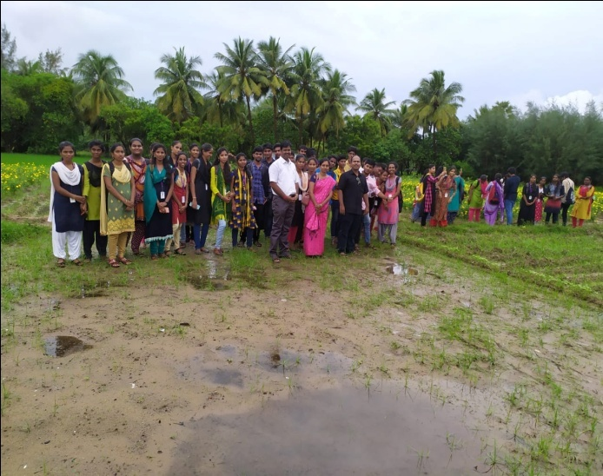

OM
MARKETING -OUR ORGANIC PRODUCTS-

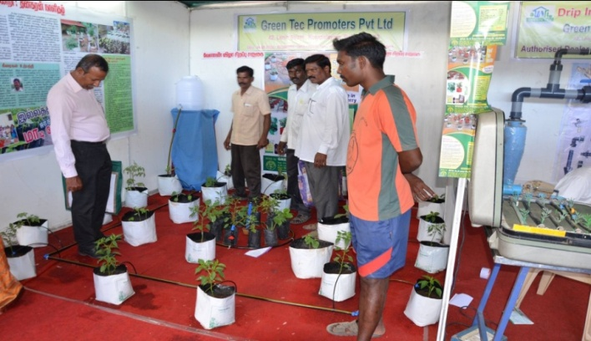
TRAINING ON COLLECTION OF SOIL SAMPLE FOR SOIL TESTING DISTRIBUTION OF SOIL HELATH CARD
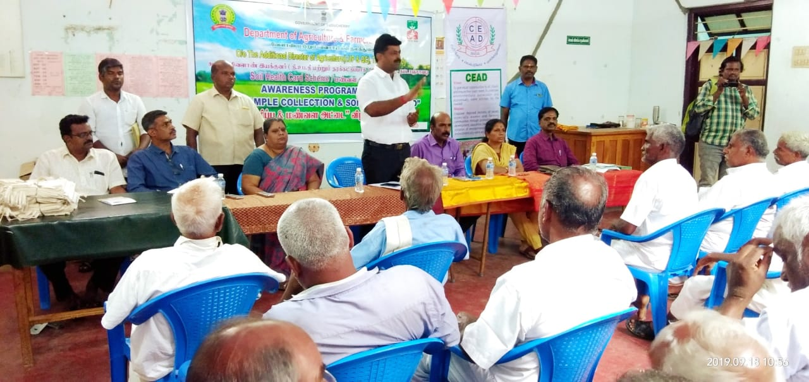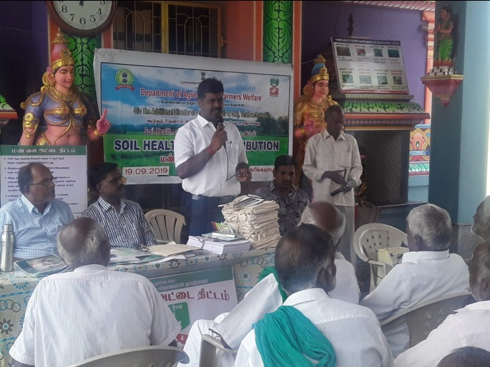
SHG DEVELOPMENT
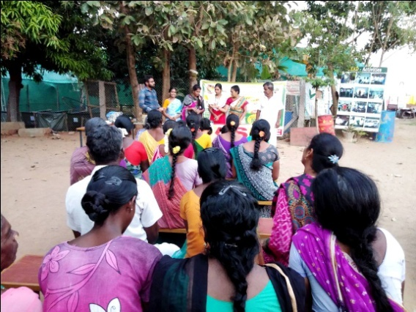

INTERNATIONAL CONFENERCE ON ENVIRONMENTAL AGRICULTURAL , CHEMICAL AND BIOLOGICAL SCIENCE(ICEACBS 2020)

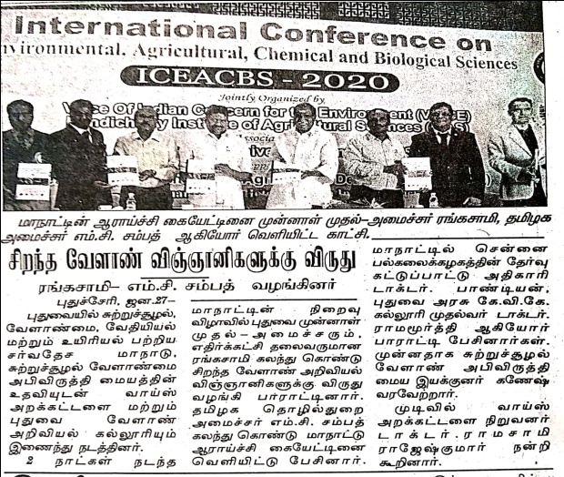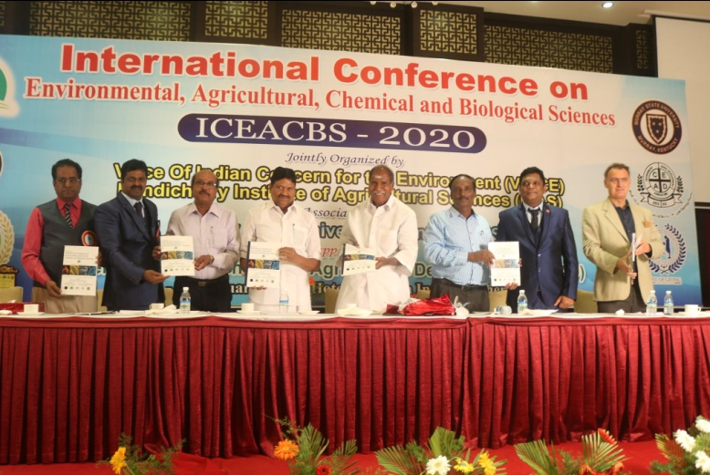
ACABC -

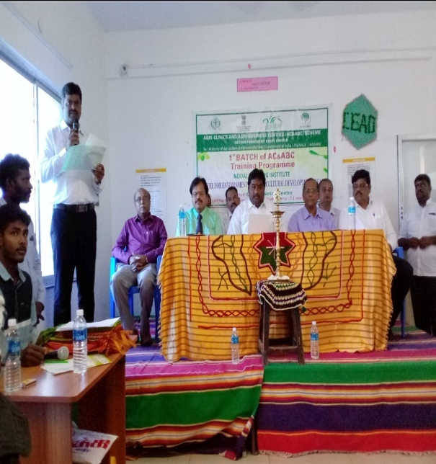

EDP TRAINING
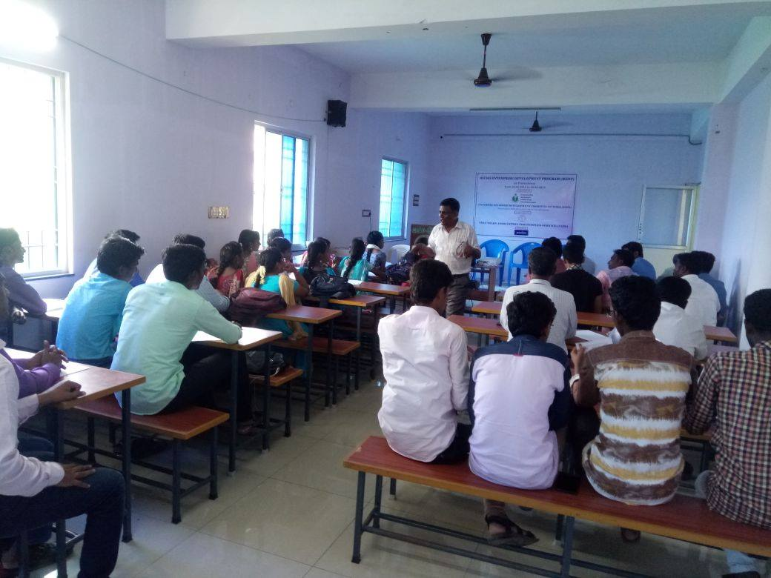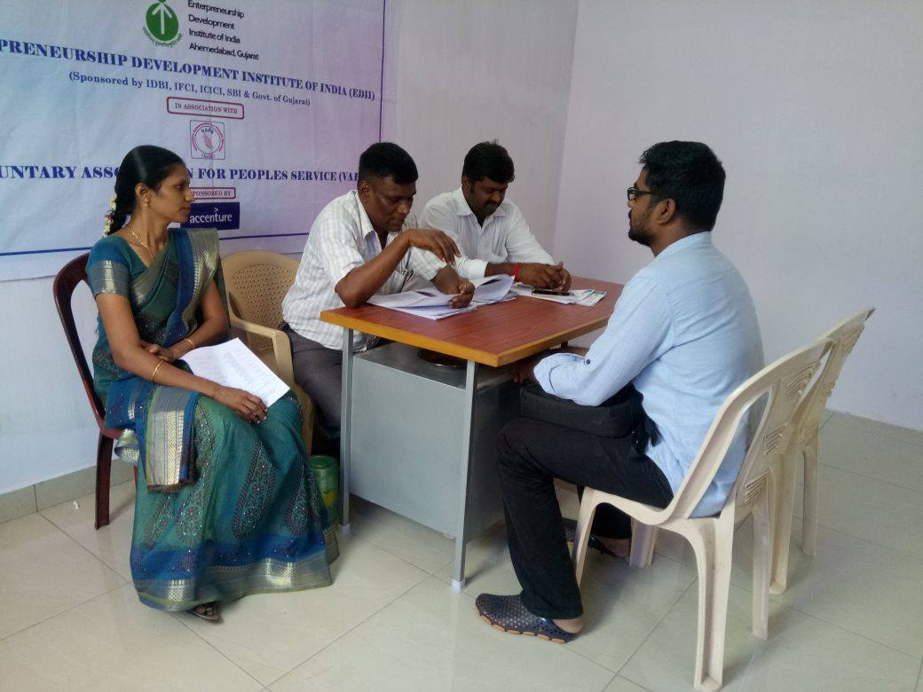
BEST NGO AWARD
